Name:_______________________ /42

**2013 Year 7 Biology Topic Test**

**Multiple Choice**

Please circle the correct answer on table below

|  |  |  |  |  |
| --- | --- | --- | --- | --- |
|  |  |  |  |  |
| **1.** | **A** | **B** | **C** | **D** |
| **2.** | **A** | **B** | **C** | **D** |
| **3.** | **A** | **B** | **C** | **D** |
| **4.** | **A** | **B** | **C** | **D** |
| **5.** | **A** | **B** | **C** | **D** |
| **6.** | **A** | **B** | **C** | **D** |
| **7.** | **A** | **B** | **C** | **D** |
| **8.** | **A** | **B** | **C** | **D** |
| **9.** | **A** | **B** | **C** | **D** |
| **10.** | **A** | **B** | **C** | **D** |
| **11.** | **A** | **B** | **C** | **D** |
| **12.** | **A** | **B** | **C** | **D** |
| **13.** | **A** | **B** | **C** | **D** |
| **14.** | **A** | **B** | **C** | **D** |
| **15.** | **A** | **B** | **C** | **D** |
| **16.** | **A** | **B** | **C** | **D** |
|  |  |  |  |  |

|  |  |  |  |  |
| --- | --- | --- | --- | --- |
|  |  |  |  |  |

1. Describe a decomposer organism.

A An animal that eats another animal

B A plant that loses its leaves in winter

C An organism that breaks down organic matter so it is recycled

D An animal that uses sound as its main method of communication

2. Identify the **biotic** factor in an organism’s environment that can affect its survival.

A The amount of water available

B The quality of the air

C Events such as fire and flood

D Competitors for living space

3. There are consequences of the introduction of the European fox into Australia in the 1860s. Select the consequence that is a **benefit** for the natural environment.

A It attacks lambs and chickens.

B It eats a wide variety of native animals.

C It eats rabbits—another introduced species.

D It provided sport for fox hunters.

4. **Deduce** which of these human activities would have a **negative** impact on a natural environment.

A Clearing forests and replacing them with exotic trees

B Removing grazing cattle from a natural woodland

C Replanting eucalypt trees

D Reintroducing koalas into eucalypt forests

5. **Deduce** which of these human activities has a **positive** effect on food webs.

A Opening up an area of bushland for recreational activities

B Removing introduced predators from an area

C Overfishing particular fish species causing a decline in numbers

D Introducing exotic species, such as rabbits and foxes

6. **Recall** the ultimate source of energy for all the organisms in a food web.

A Soil for providing essential minerals

B Water to prevent dehydration

C Green plants for photosynthesis

D The Sun for providing light

7. **Define** an organism’s habitat.

A The place where the organism lives

B The place where the organism is at a point in time

C The place where all the abiotic factors are suited to the organism’s survival

D A place where the organism hunts for food

8. **Define** adaptations.

A Living factors that influence where an organism lives

B Non-living factors that influence where an organism lives

C Features of an organism that help it survive in its environment

D Organisms that inhabit a specific region

9. **Identify** the term that is defined by the following: ‘an interaction between organisms in which both the organisms benefit from the relationship and neither is harmed’.

A Parasitism

B Commensalism

C Mutualism

D Competition

10. **Identify** the term that is defined by the following: ‘an interaction between two organisms in which one of them benefits but the other one is not affected’.

A Competition

B Parasitism

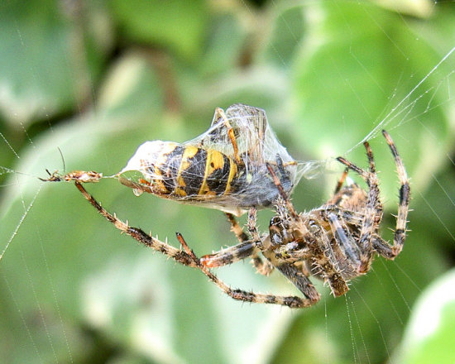C Mutualism

D Commensalism

11. **Deduce** the relationship between the two animals in this photograph.

A Parasite/host

B Predator/prey

C Commensalism

D Mutualism

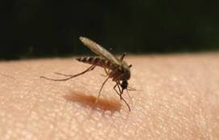12. **Deduce** the relationship between the mosquito and the human whose arm can be seen in the photograph.

A Predator/prey

B Commensalism

C Mutualism

D Parasite/host

13. **Interpret** the food web then identify the organisms that are **third-order** consumers.

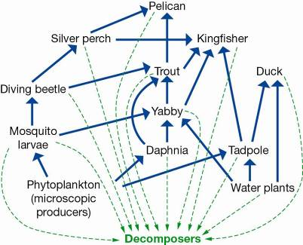

A Silver perch, trout, pelican

B Kingfisher, daphnia, trout

C Silver perch, tadpole, duck

D Pelican, duck, daphnia

14. **Identify** the food chain that is part of this food web.



A Phytoplankton -> daphnia -> trout -> duck -> decomposers

B Water plant -> tadpole -> trout -> kingfisher -> decomposers

C Phytoplankton -> mosquito larvae -> yabby -> silver perch -> pelican -> decomposers

D Water plant -> yabby -> trout -> kingfisher -> decomposers

15. Adelie penguins live in Antarctica where it is very cold all year round. They get all their food from the ocean and have to be able to swim fast to escape predators. **Deduce** which of the adaptations of penguins listed below is of **least** benefit to their survival in the Antarctic.

A They have short, stocky bodies that reduce the amount of heat that is lost.

B They catch and swallow their live prey whole.

C Their feathers are densely packed and along with oil from oil glands they provide a totally waterproof layer.

D The bones in the wings are fused and flattened to form strong paddle-like wings.

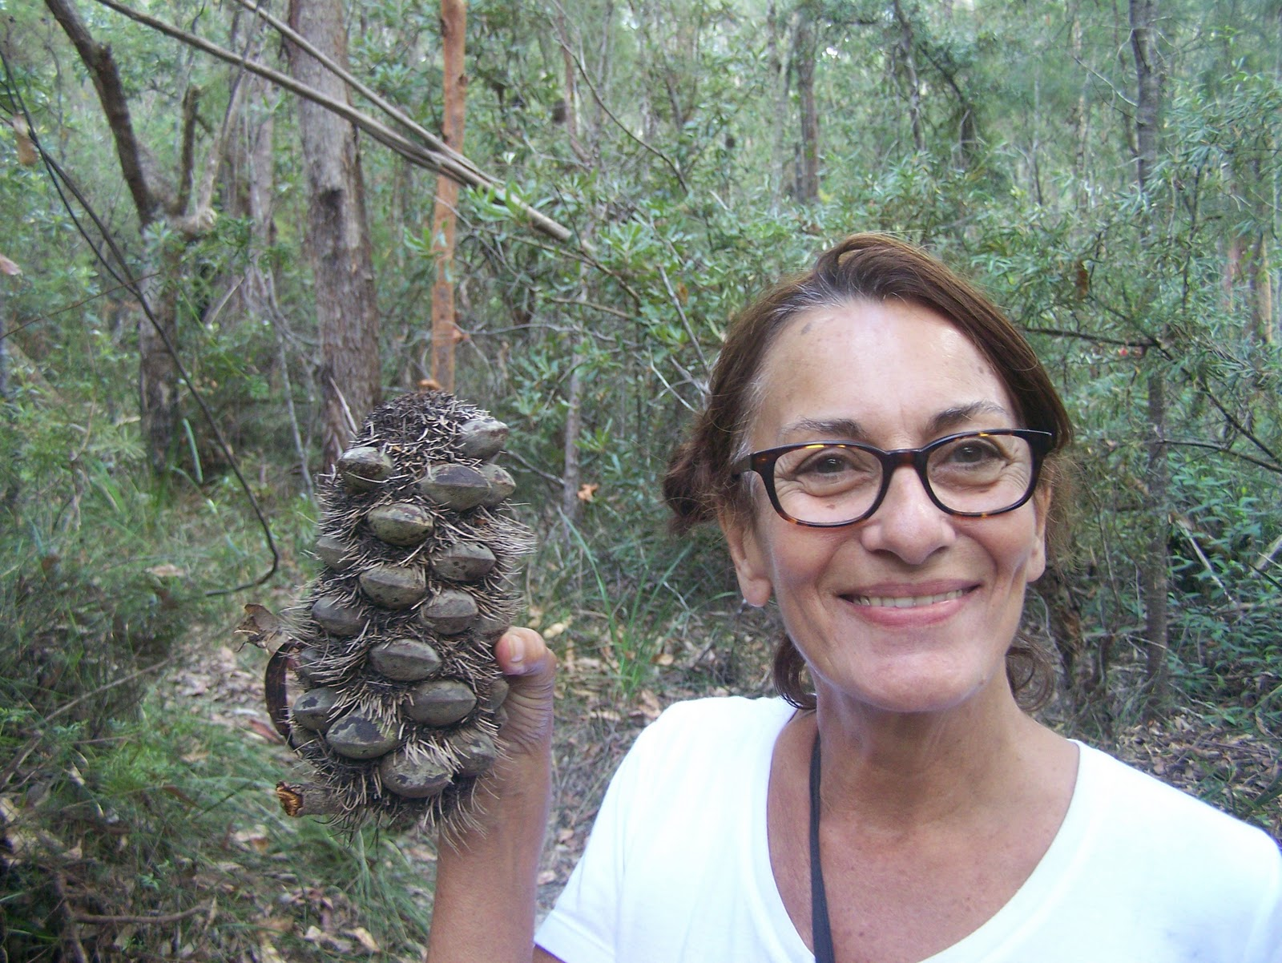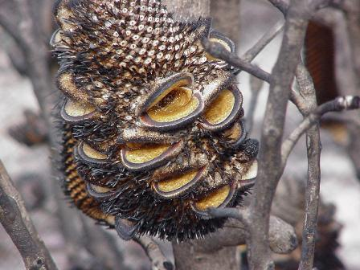16. The two photographs to the right are of part of a banksia tree showing the fruit that contains the seeds. The pictures show the tree before and after a fire. **Deduce** the effect of the fire.

Before Fire

After

Fire

A The fire burns the tree and fruit, killing the tree and any seeds.

B The fruit explodes and the seeds are destroyed.

C The fire dries the fruit, which opens, allowing the seeds to come out.

D The fire just causes the tree and the fruit to turn black.

**Short Answer Section**

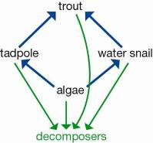

Please write your answers in the spaces provided

1. The diagram represents a food web in a freshwater lake.

a) **Deduce** the effect on the population of water snails if the trout were fished out of the lake by fishing enthusiasts.

(1 mark)

b) **Explain** your answer

________________________________________________________________________________________________________________________________________________________________________________________________________________________________________________________________________________________________________________________________ (1 mark)

2. Since European settlement in Australia, more than 50% of eucalypt forests and about 75% of rainforests have been removed. Explain how increasing the native vegetation cover in Australia by planting more native trees and shrubs could benefit native plants and animals.

**Deduce** whether each of the statements listed are **true or false**. Write T or F in the box.

a) T The wind is a part of an organism’s environment.

b) T Parasitism is an interaction in which one type of organism lives on or in another type of organism and usually causes it harm.

c) T The forest that includes a tree in which a spider lives is regarded as the spider’s habitat.

d) T Endangered species are close to extinction and very small numbers remain.

e) Sustainable ecosystems are ecosystems able to provide for the needs of the F organisms living there for a short period of time.

(5 marks)

3. Use your knowledge and the food chain below to answer the following questions.

Grass -> grasshopper -> frog -> snake -> kookaburra

_P_ __C__ __C_ _C_ __C__

a) **Classify** the organisms in this food chain as producers and consumers by writing a **P or C** under each organism. (5 marks)

b) Explain why producers and consumers are given the names ‘producers’ and ‘consumers’.

* Producers – Make substances by the process of photosynthesis
* Consumers – Consume/ eat the producer organisms (2 marks)

4. Study the diagram shown, which represents a food web in a freshwater creek.

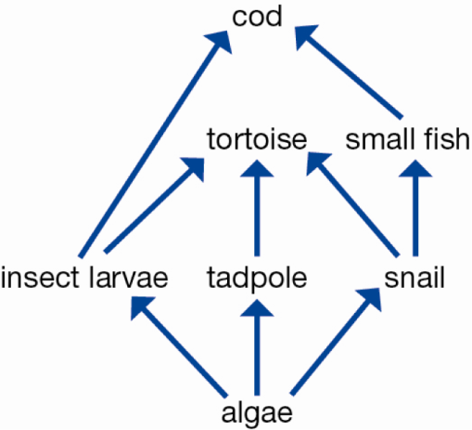

a) **Explain** what the arrow between two organisms means.

Arrow = passing on of energy ------ a feeding relationship (1 mark)

b) **Identify** and record **TWO different food chains** that include the tortoise.

(use words not diagrams) (2 marks)

c) **Explain** why this community could not survive without the algae.

The algae is the producer organism and without algae all consumers along the chain will die

(2 marks)

5. The spinifex hopping mouse shown in the photo is native to the central Australian desert. It is active at night and shelters in a complex burrow system during the day.

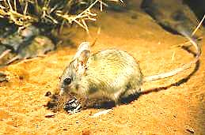

**Describe** two characteristics of the organism that are adaptations to living in the hot desert and being active at night. (2 marks)

1:

2:

6. These three images are of birds that eat very different food.

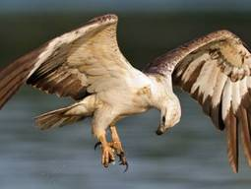

Eagles swoop down from a great height to catch live mice and other small animals for food.

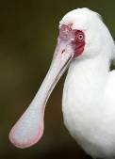

Spoonbills sift through the mud for small insects and crabs to eat.

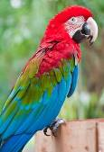

Parrots bite and tear at fruit. They also crack open seeds to get at the soft kernels inside.

**Deduce** from the information and photographs provided the **adaptations** these three birds have that enable them to access the food they eat. (3 marks)

Eagle:_________________________________________________________________________________________________________________________________________________________________________________________________________________________________________________

Spoonbill:______________________________________________________________________________________________________________________________________________________________________________________________________________________________________________

Parrot:_________________________________________________________________________________________________________________________________________________________________________________________________________________________________________________

7. A type of bird called a **cattle egret** feeds on insects, especially grasshoppers, flies (adults and maggots) and moths. Cattle egrets are usually found with cattle and other large grazing and browsing animals. Scientific studies have shown that cattle egrets find more food when they are near a large animal than when feeding on their own. The cattle are not affected by the egrets in any way.

**[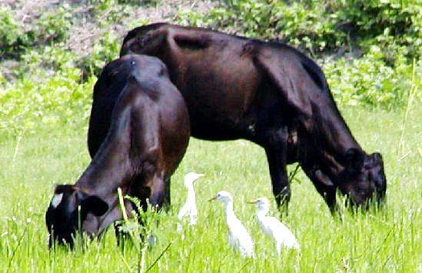](http://www.itsnature.org/wp-content/uploads/2010/08/cattle_egret.jpg)**

a) **State** the type of **relationship** that exists between the cattle egret and the cattle.

(Commensalism, mutualism or parasitism)

MUTUALISM

(1 mark)

b) **Justify** (explain) your decision.

(1 mark)

End of test --- check through your answers